**How to use RecoveryTool~SUV!T.exe**

1. Download RecoveryTool~SUV!T.exe and open (no need to install).

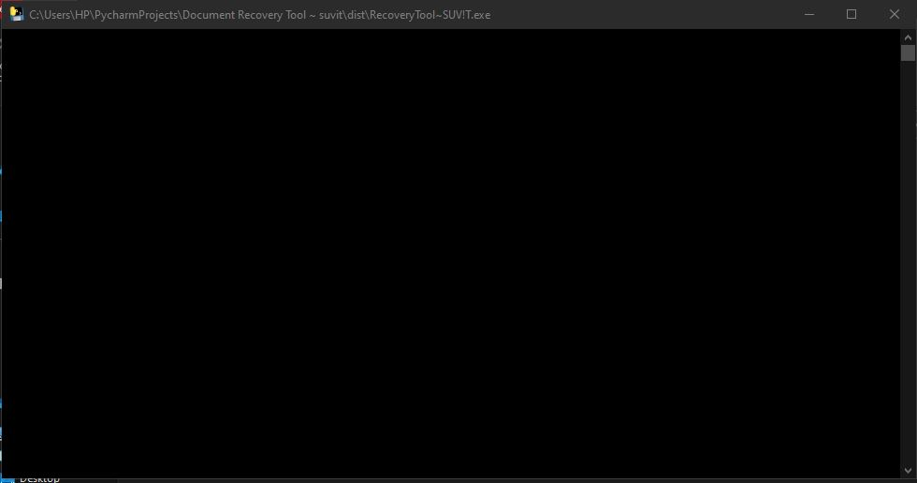

1. Wait for some time, program will ask you to enter directory of corrupted word file of format .docx or .doc

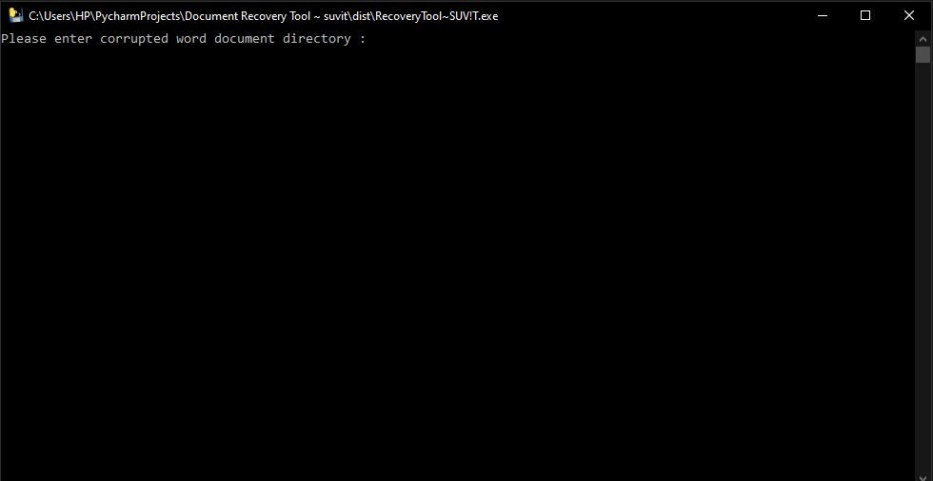

1. Now enter correct and complete directory to your corrupted word file.

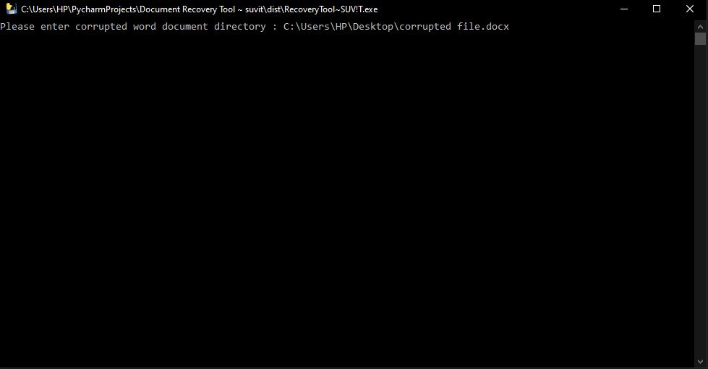

1. Hit enter and wait for web browser to open. In a new browser window, you will get all your text WITHOUT ANY FORMATING.

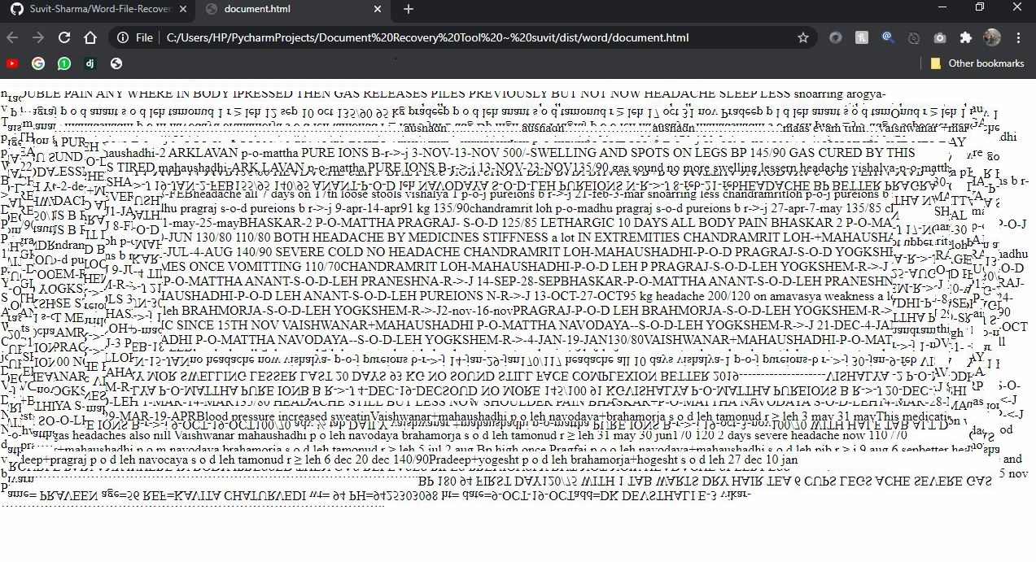

**DUE TO PRIVACY REASON TEXT IN THE BROWSER WINDOW IS EDITED**

1. **(IMPORTANT)** Go back to application and press any key to exit, else it may cause trouble next time .

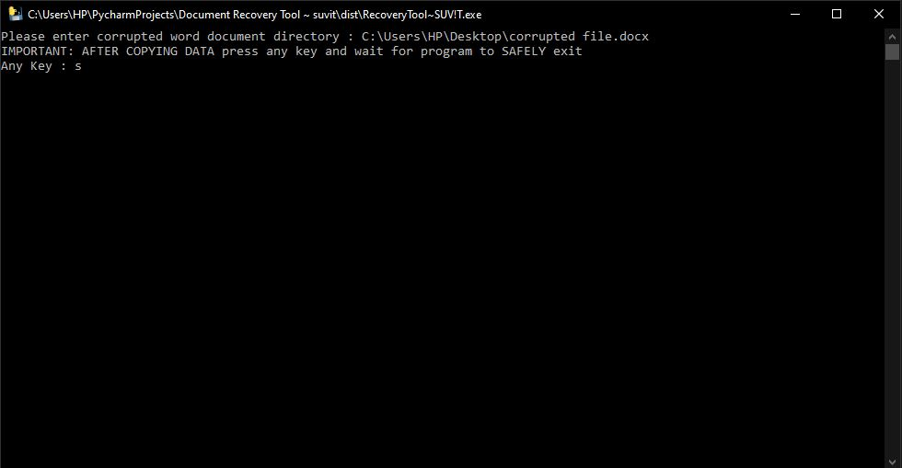

**If it helped you please share it ☺**